PHI

(Promise House Inventory)

Manual

By

Tanaka Mazivanhanga

Matthew Chu

Jake Carney

Pranaya Kalidindi

Hao Zhou



1. **General Information**

The general information section of the manual presents a general overview of the program and the organization of this manual.

* 1. **Software Overview**

The main goal of PHI is to provide an efficient environment for The Promise House to keep track of its inventory. This software provides a platform where the donated goods with an UPC code can be scanned into the system and later the inventory can be handled digitally. There are three main properties in PHI to handle the inventory: Scanning in good, manually manipulating the inventory and generating reports of the inventory.

The scanner is used to read the UPC barcode on the product. The price of the product uploads automatically from the UPC Database. The quantity, weight and the date that product is donated are necessary fields to be filled while doing inventory. The goods can be categorized in the present categories provided like Food, Supplies and Toiletries. Any additional categories can be added if required. Products can also be added to the inventory manually by typing the necessary information. The application can generate reports containing the inventory on the click of one button.

* 1. **Organization of the Manual**

This organization is organized into four parts: General Information, System Summary and Getting Started.

General Information explains the purpose of the software and provides information about the manual.

System Summary provides an overview of the system’s hardware and software requirements, user access levels.

Getting started explains how to run the application in order to use it. It summarizes the features of the application and explains the user how to use these features.

1. **System Summary**
   1. **System Configuration**

PHI will operate only on Desktop or Laptop computers; it currently will not support mobile devices. It will be coded and run using primarily Java. The hardware needed for the application should not be very demanding. You will need to meet the minimum requirements to run PHI:

* CPU: Intel Core i3-3210 3.2 GHz / AMD A8-7600 APU 3.1 GHz or equivalent
* RAM: 2GB
* The basic software requirement for this software would be a computer that can run java and is installed with a java editor that can run the program.
* Compatible with a NADAMOO bar code scanner  (or any scanner that can be generally accepted).
  1. **User Access Levels**

Anyone who is allowed to access the Promise House Inventory can use this software.

1. **Getting Started**

This section shows all the features of PHI and how to use them.

* 1. **Start Window**

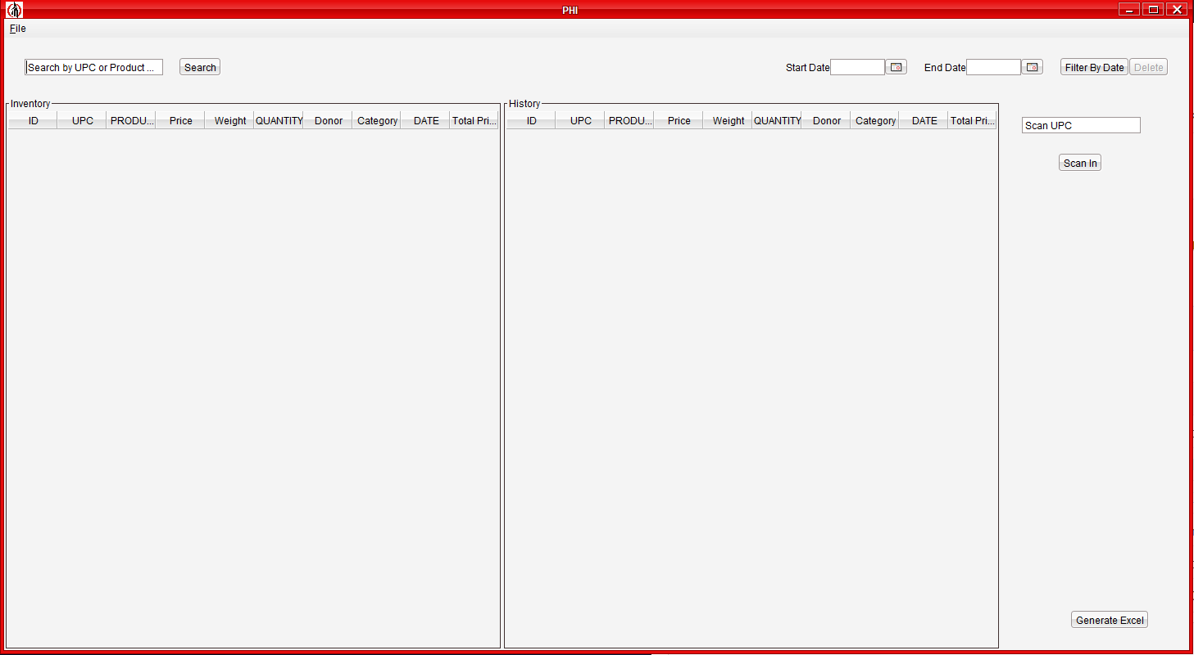

* 1. **Adding Goods to Inventory**
     1. **Scanning with Scanner**

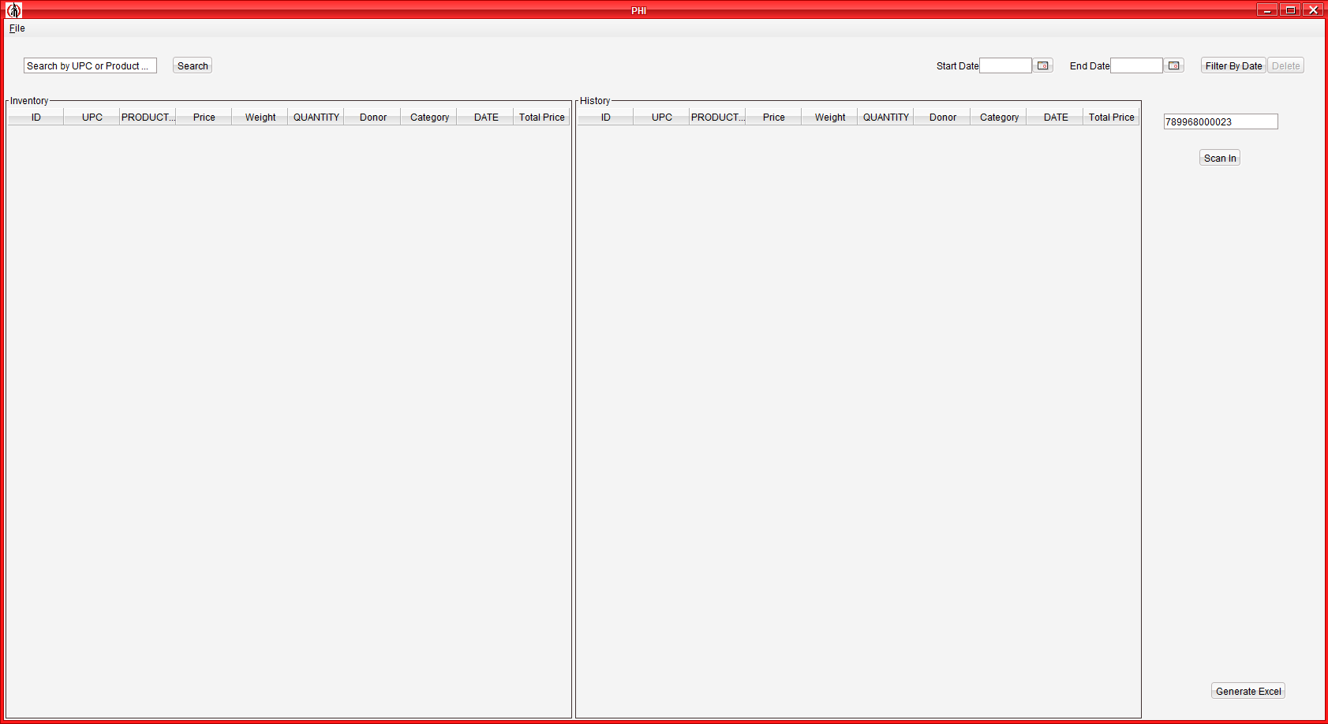

When scanned with a scanner, the UPC code is directly entered into this field. Press the Scan In button to continue.

The UPC, Name of the product and the Price of the product would already be filled, if the UPC code is valid.

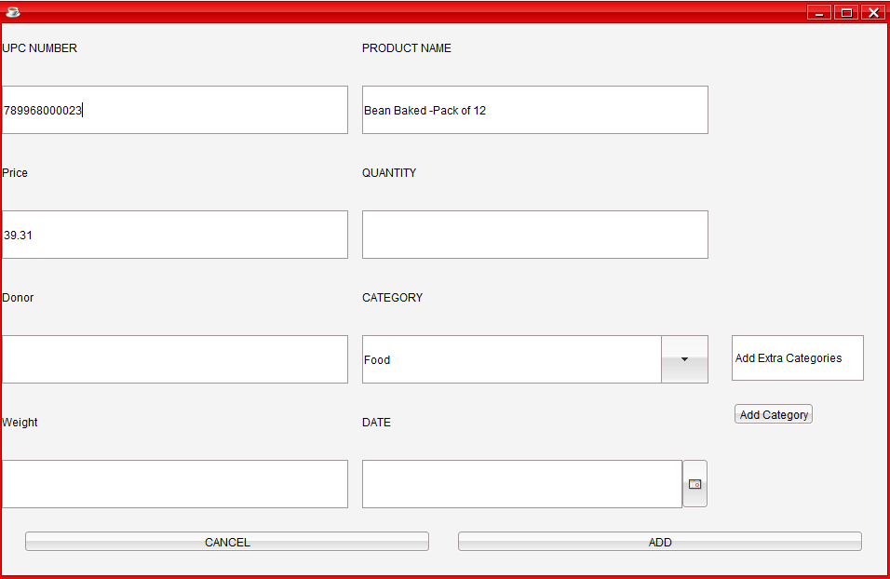

The Quantity, Weight and Date of Donation are fields that need to be filled in order to proceed further. The Donator’s name is Optional.

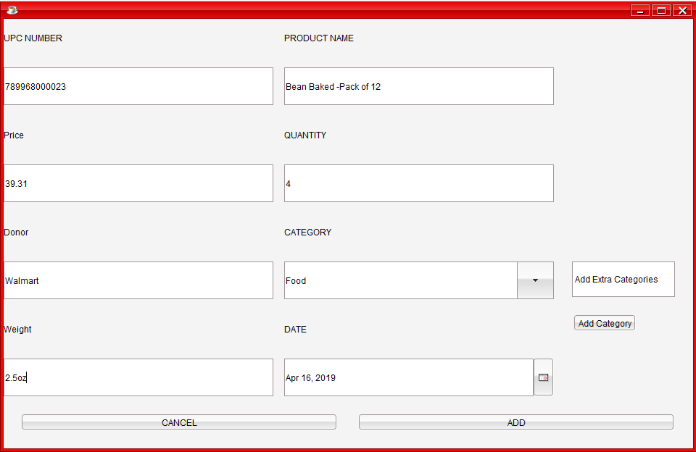

There is one more feature that can be utilized in this window: Category

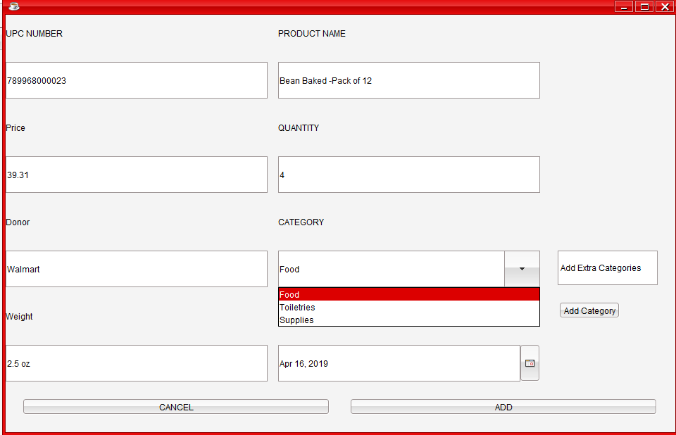

The ‘Food’ category is selected by default.

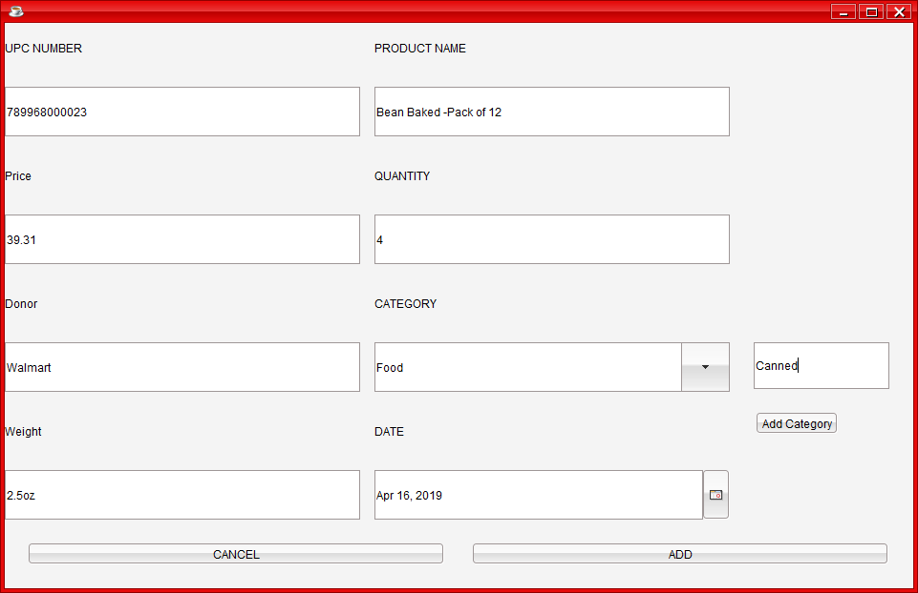

If you want to add a new category, type the category’s name in the field, and press the button ‘Add Category’.

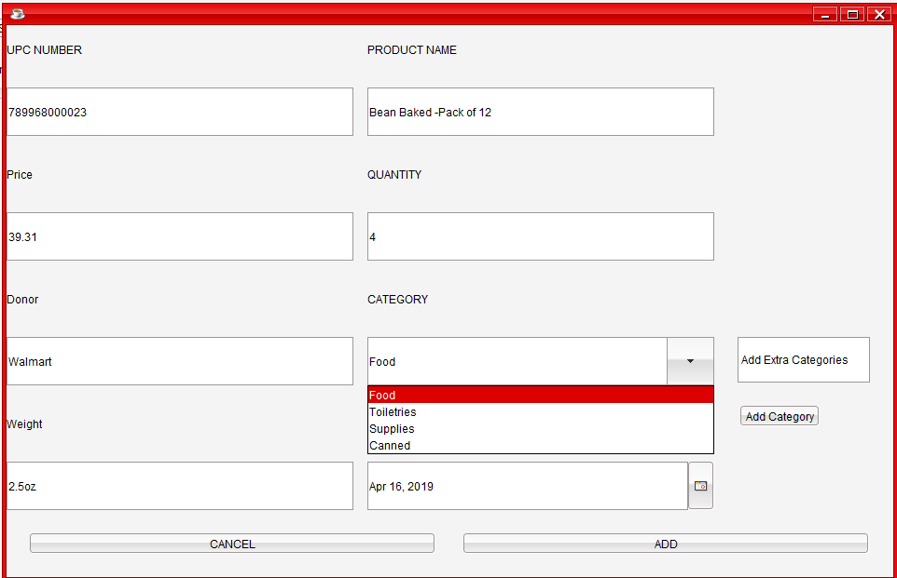

We can view the added category in the drop-down menu.

We can now see the product in the inventory.

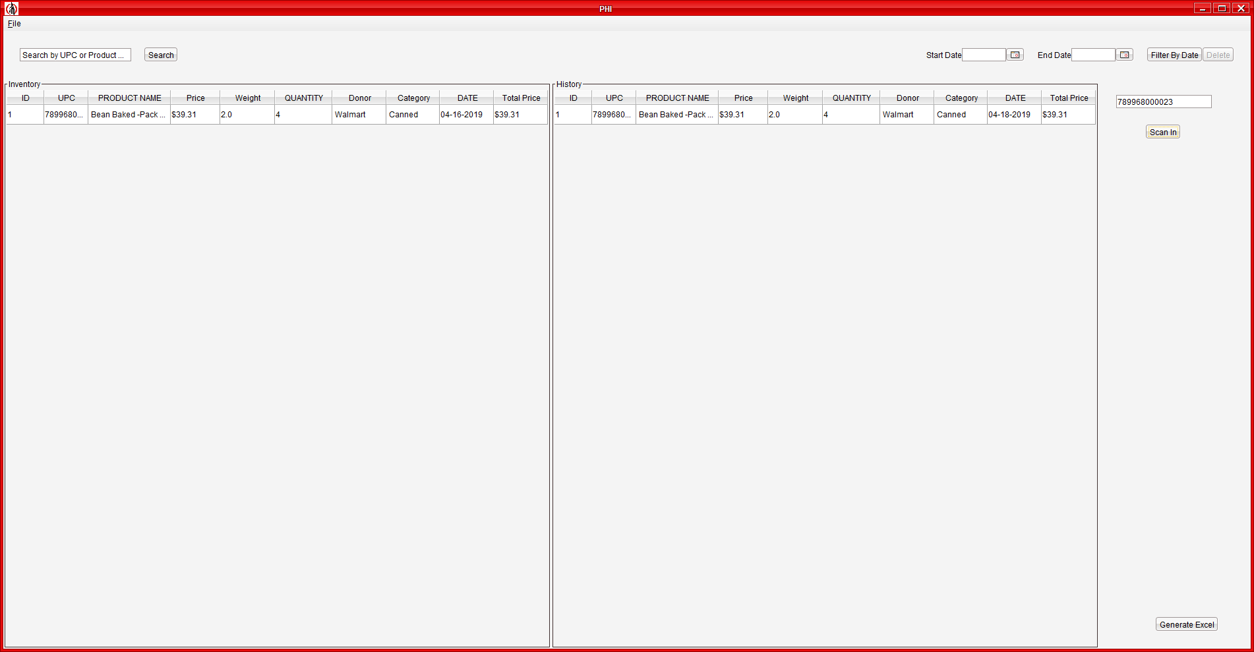

**3.2.2. Adding goods Manually**



If you want to add in a product manually without a product, just click on the ‘Scan-In’ Button.

The UPC number would be automatically set to 0. All the other boxes follow the same procedure as mentioned in 3.2.1.

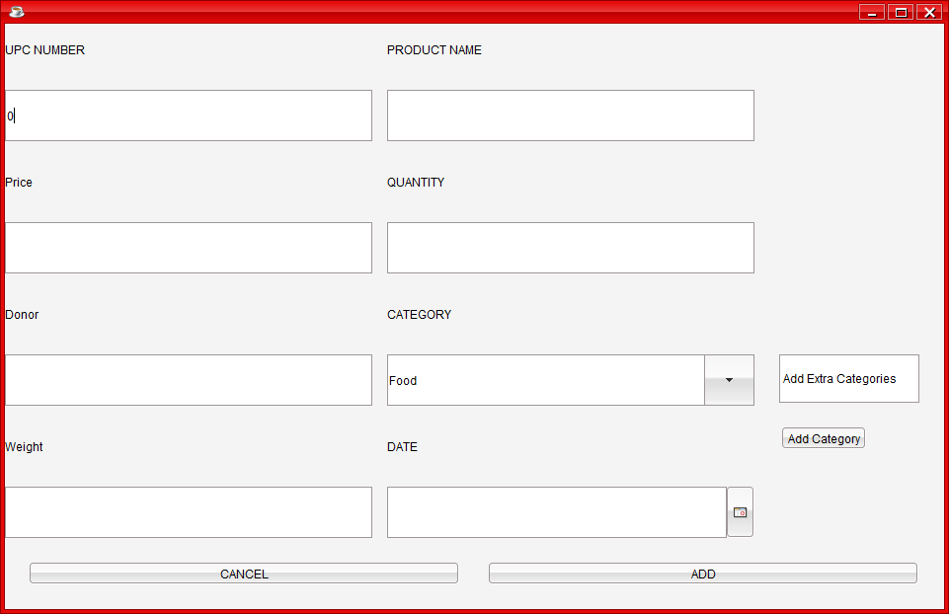

* 1. **Editing the inventory**

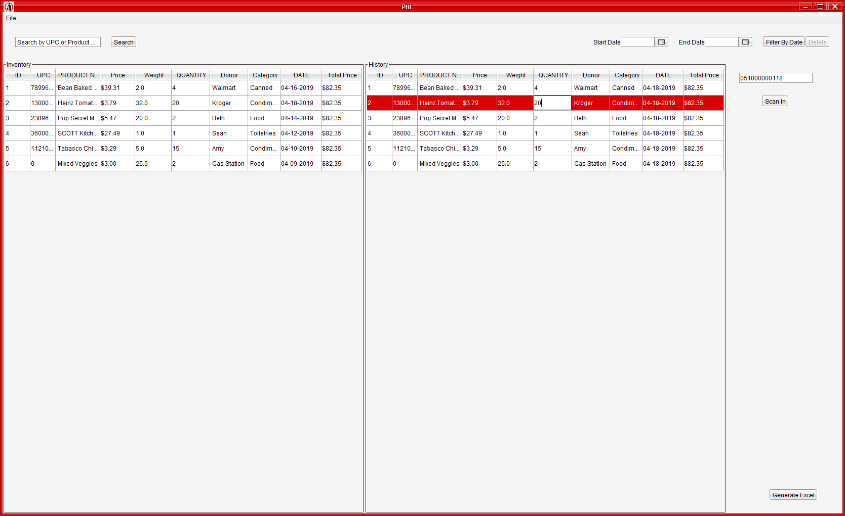

To edit an inventory, you need to just double-click on the box that you want to edit, like shown above.

* 1. **Filters**

The inventory can be filtered in two ways:

* + 1. **By UPC Number/ Product Name**

Type the UPC number or Product Name in order to filter the inputs as shown.

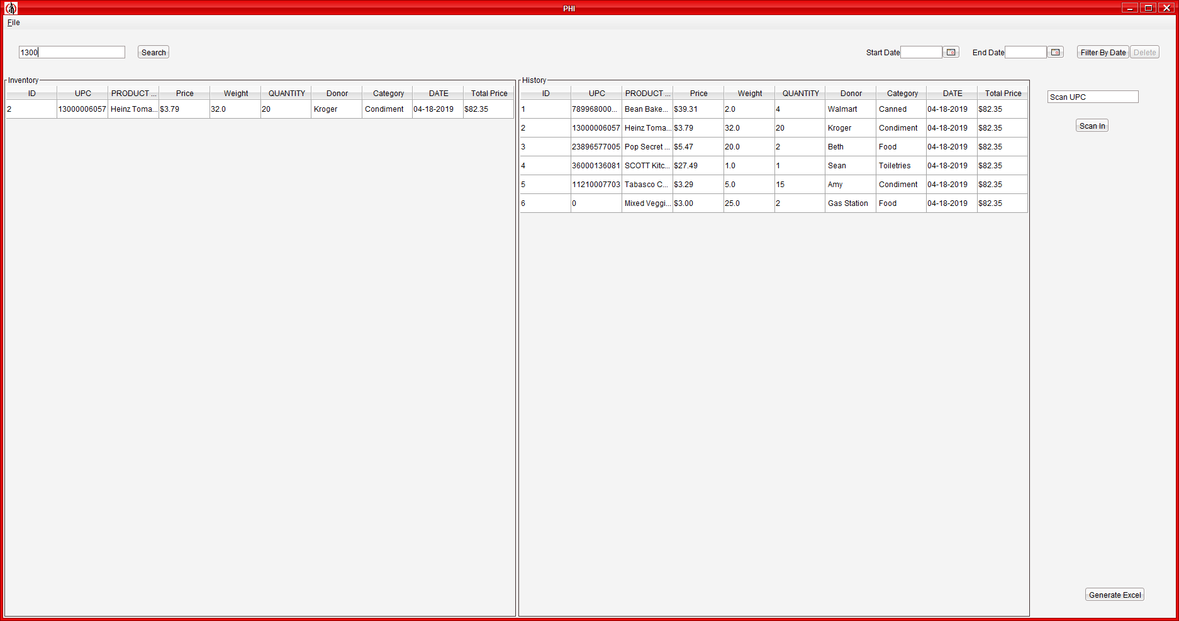

* + 1. **By Donation Dates**

Selected the date range required to see what items where added to the inventory in that time period.

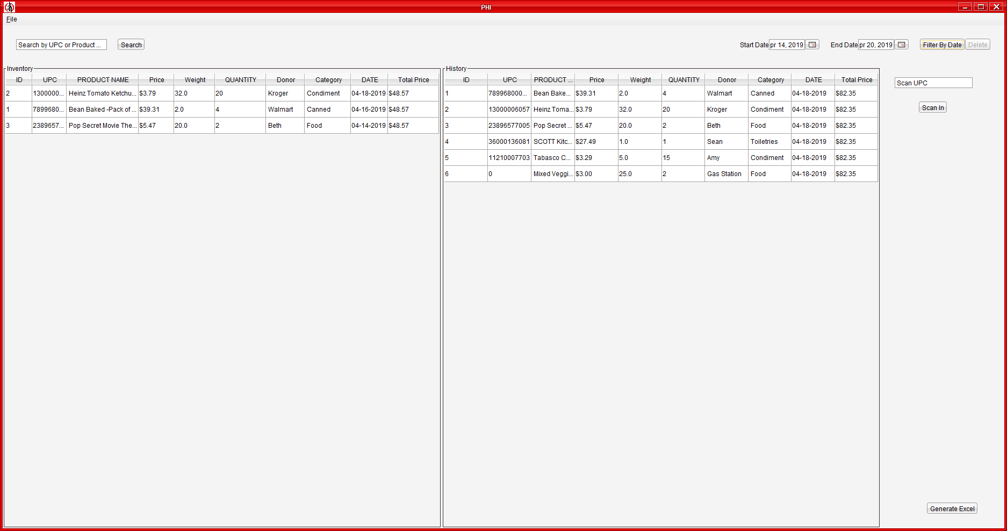

* 1. **Generating Reports**

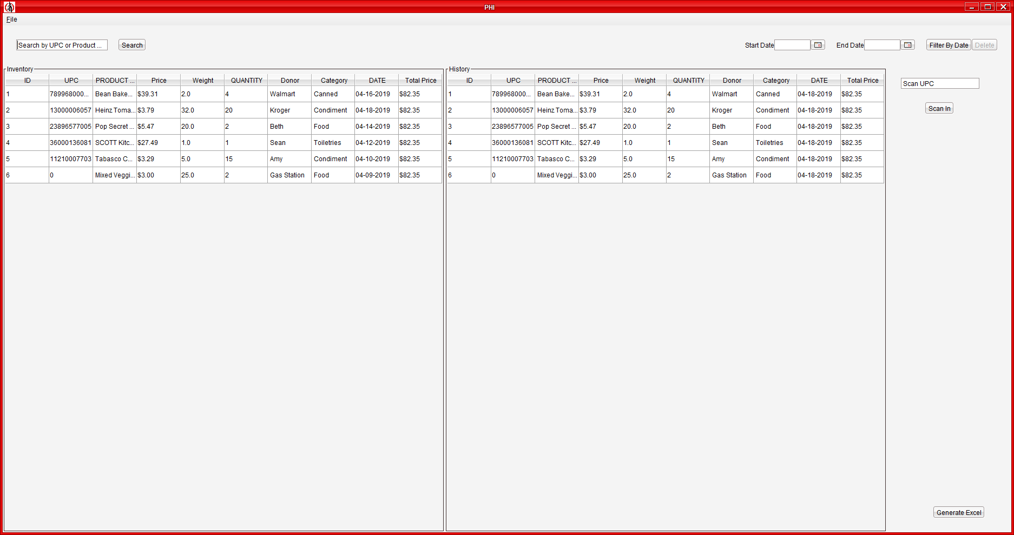

Click on ‘Generate Excel’ button in order to generate an excel sheet of the products selected.

You will be prompted with a dialogue box for the name of the excel sheet.

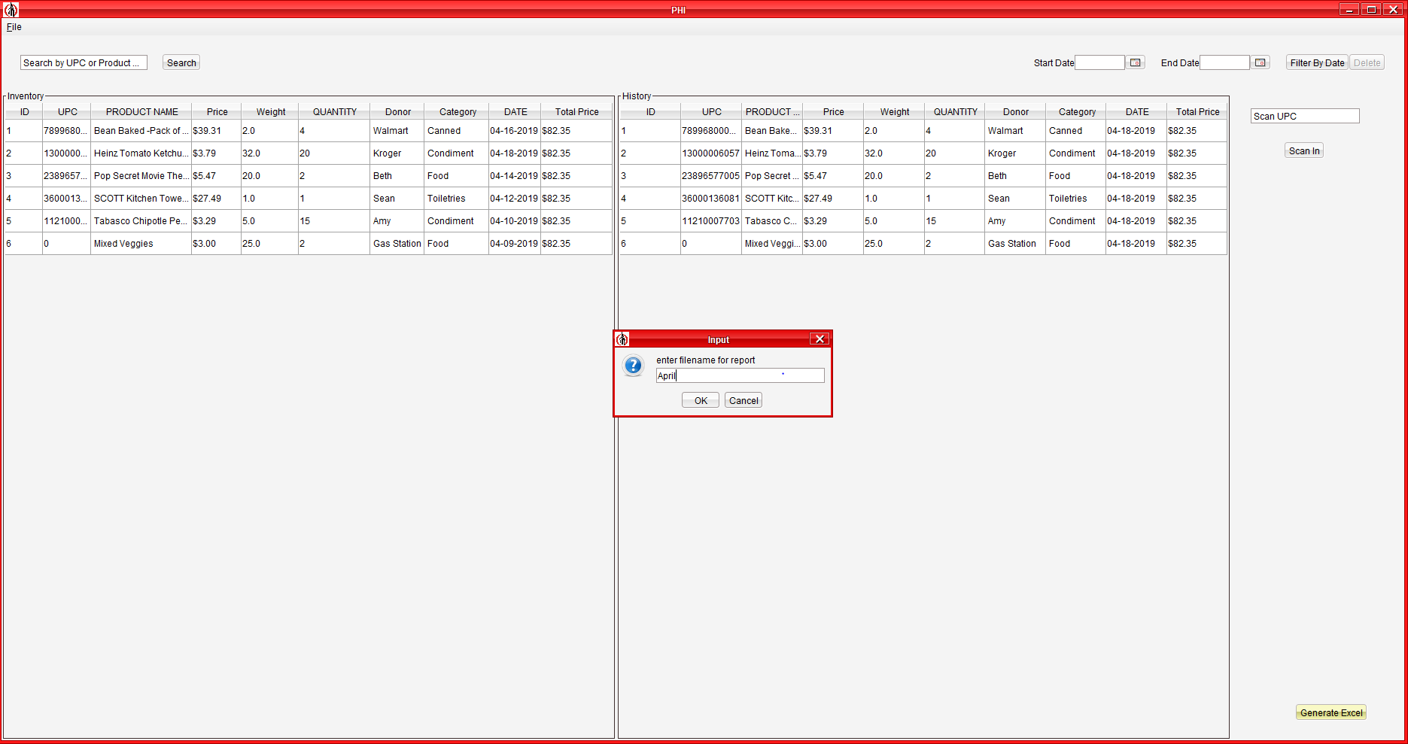

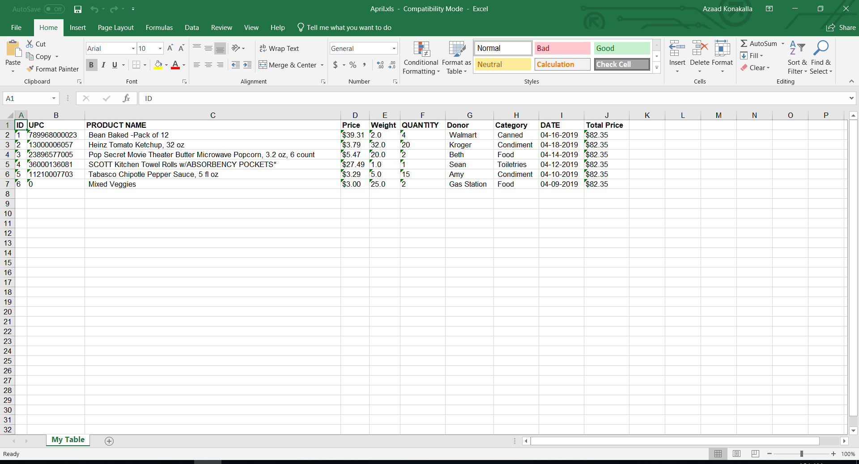

1. **Addendum**

* A scan-out button could be added, so that it becomes easier to remove products from the inventory.
* We could create a webpage for the inventory so that people with access can access it remotely.
* We can provide access controls by adding log-in credentials connected to the Promise House.

1. **Testing**

**Scenario Test**

Jake donated a case of fruit snacks to the Promise House. Tanaka scanned the case into the Promise House and put Jake as the donor, 1 as the quantity, 45 as the weight, April 17th as the date and food as the category. Then Tanaka had to generate a report for April.

Result: When the case of fruit snacks was scanned, mostly all the fields were autofilled. All Tanaka had to do was fill in the date field, the donor field, the weight field, the quantity field, and the category field. This resulted in all the fields being correctly added to the database and displayed on the history and inventory tables. Tanaka then clicked on the generate excel button and named it “April2019”. An excel file then opened and it had the right information in the right cells.

**User Test**

**Instructions:**

* Open the application.
* Scan the items given to you & fill in the rest of the fields.
* Add the item to the inventory.
* Generate an excel report.

#Example 1 Josh Davis (1 item):

**Result:** Scanned the item with no problems and filled in fields. Only error was that he put “3.8oz” at first instead of “3.8”. Found and used the “Generate Excel” button quickly.

**Comments:** “I feel like you definitely could quickly teach somebody how to use this. It is a pretty straight forward application.”

#Example 2 Cameron Liford (2 items):

**Result:** Had him type a UPC in instead of scanning it. This resulted in him filling out every field. Did everything fine except for filling out the price. He put “$5.00” instead of 5.00. Then I had him scan the second item and did not tell him what to do. He filled out the fields rather quickly. I then told him to generate a report and name it whatever he liked. He completed the task within 10 seconds.

**Comments:** “It was easy to use. Felt like I knew the ropes without being told the details of it. I think this would work great in a small business.”